**1/3 Практическое задание**

* скриншоты наличия объектов в Active Directory;

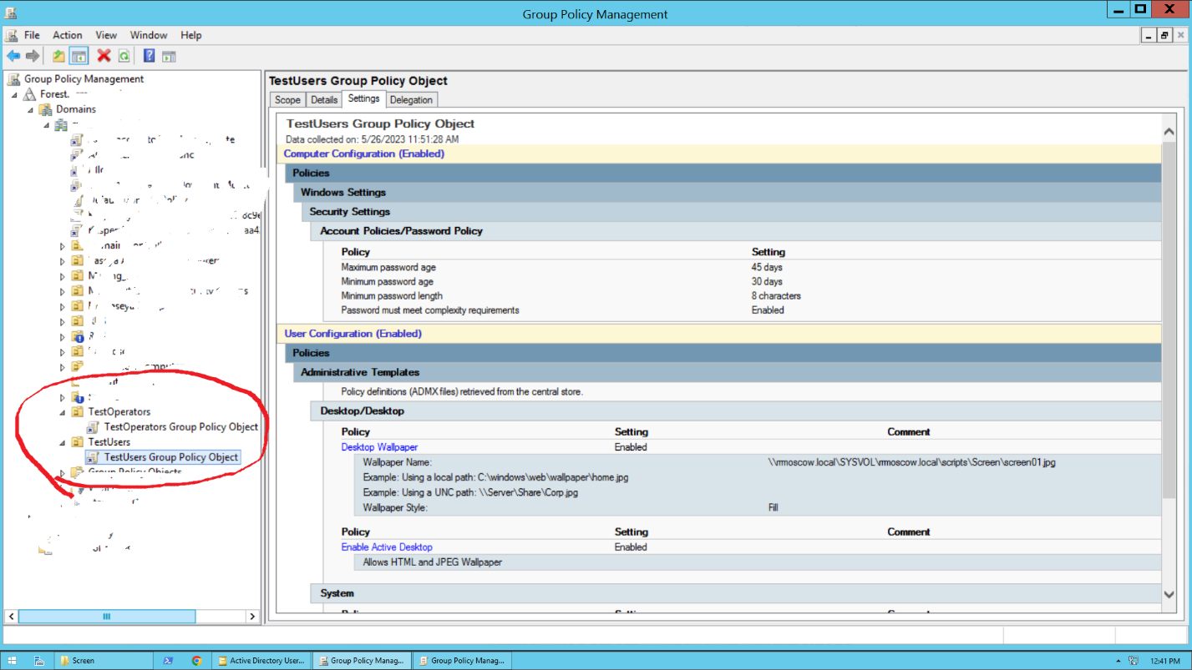

* скриншоты входа на SF_CLIENT под доменными пользователями с разными ролями  
  *- тут я входил со своего компа в свой домен под этими тестовыми учетками*

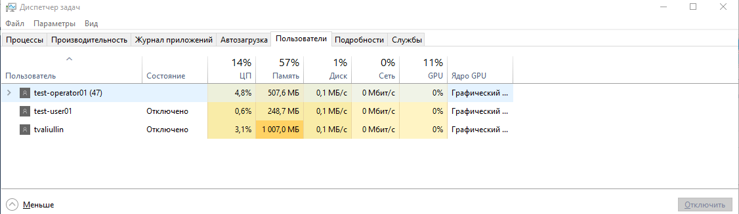

* созданные политики в текстовом виде (как вариант: вывод команд gpresult /scope computer и gpresult /scope user для каждой роли);

|  |  |
| --- | --- |
| **TestUsers Group Policy Object** | |
| Data collected on: 5/26/2023 11:51:28 AM |  |

**General**

**Details**

|  |  |
| --- | --- |
| Domain | rrmoscow.local |
| Owner | RRMOSCOW\Domain Admins |
| Created | 5/26/2023 10:30:58 AM |
| Modified | 5/26/2023 11:22:58 AM |
| User Revisions | 4 (AD), 4 (SYSVOL) |
| Computer Revisions | 14 (AD), 14 (SYSVOL) |
| Unique ID | {C95504D7-852F-4B2C-925F-6C8C80DD502C} |
| GPO Status | Enabled |

**Links**

|  |  |  |  |
| --- | --- | --- | --- |
| **Location** | **Enforced** | **Link Status** | **Path** |
| TestUsers | No | Enabled | rrmoscow.local/TestUsers |

This list only includes links in the domain of the GPO.

**Security Filtering**

**The settings in this GPO can only apply to the following groups, users, and computers:**

|  |
| --- |
| **Name** |
| NT AUTHORITY\Authenticated Users |

**Delegation**

**These groups and users have the specified permission for this GPO**

|  |  |  |
| --- | --- | --- |
| **Name** | **Allowed Permissions** | **Inherited** |
| NT AUTHORITY\Authenticated Users | Read (from Security Filtering) | No |
| NT AUTHORITY\ENTERPRISE DOMAIN CONTROLLERS | Read | No |
| NT AUTHORITY\SYSTEM | Edit settings, delete, modify security | No |
| RRMOSCOW\Domain Admins | Edit settings, delete, modify security | No |
| RRMOSCOW\Enterprise Admins | Edit settings, delete, modify security | No |

**Computer Configuration (Enabled)**

**Policies**

**Windows Settings**

**Security Settings**

**Account Policies/Password Policy**

|  |  |
| --- | --- |
| **Policy** | **Setting** |
| Maximum password age | 45 days |
| Minimum password age | 30 days |
| Minimum password length | 8 characters |
| Password must meet complexity requirements | Enabled |

**User Configuration (Enabled)**

**Policies**

**Administrative Templates**

Policy definitions (ADMX files) retrieved from the central store.

**Desktop/Desktop**

|  |  |  |
| --- | --- | --- |
| **Policy** | **Setting** | **Comment** |
| Desktop Wallpaper | Enabled |  |
| |  |  | | --- | --- | | Wallpaper Name: | \\rrmoscow.local\SYSVOL\rrmoscow.local\scripts\Screen\screen01.jpg | | Example: Using a local path: C:\windows\web\wallpaper\home.jpg | | | Example: Using a UNC path: \\Server\Share\Corp.jpg | | | Wallpaper Style: | Fill | | | |
| **Policy** | **Setting** | **Comment** |
| Enable Active Desktop | Enabled |  |
| |  | | --- | | Allows HTML and JPEG Wallpaper | | | |

**System**

|  |  |  |
| --- | --- | --- |
| **Policy** | **Setting** | **Comment** |
| Prevent access to registry editing tools | Enabled |  |
| |  |  | | --- | --- | | Disable regedit from running silently? | Yes | | | |

**System/Ctrl+Alt+Del Options**

|  |  |  |  |
| --- | --- | --- | --- |
| **Policy** | | **Setting** | **Comment** |
| Remove Change Password | | Enabled |  |
| **TestOperators Group Policy Object** | | | |
| Data collected on: 5/26/2023 12:28:11 PM |  | | |

**General**

**Details**

|  |  |
| --- | --- |
| Domain | rrmoscow.local |
| Owner | RRMOSCOW\Domain Admins |
| Created | 5/26/2023 10:31:18 AM |
| Modified | 5/26/2023 12:28:04 PM |
| User Revisions | 7 (AD), 7 (SYSVOL) |
| Computer Revisions | 16 (AD), 16 (SYSVOL) |
| Unique ID | {8505C545-6512-4C7E-AB48-12C3A544C478} |
| GPO Status | Enabled |

**Links**

|  |  |  |  |
| --- | --- | --- | --- |
| **Location** | **Enforced** | **Link Status** | **Path** |
| TestOperators | No | Enabled | rrmoscow.local/TestOperators |

This list only includes links in the domain of the GPO.

**Security Filtering**

**The settings in this GPO can only apply to the following groups, users, and computers:**

|  |
| --- |
| **Name** |
| NT AUTHORITY\Authenticated Users |

**Delegation**

**These groups and users have the specified permission for this GPO**

|  |  |  |
| --- | --- | --- |
| **Name** | **Allowed Permissions** | **Inherited** |
| NT AUTHORITY\Authenticated Users | Read (from Security Filtering) | No |
| NT AUTHORITY\ENTERPRISE DOMAIN CONTROLLERS | Read | No |
| NT AUTHORITY\SYSTEM | Edit settings, delete, modify security | No |
| RRMOSCOW\Domain Admins | Edit settings, delete, modify security | No |
| RRMOSCOW\Enterprise Admins | Edit settings, delete, modify security | No |

**Computer Configuration (Enabled)**

**Policies**

**Windows Settings**

**Security Settings**

**Account Policies/Password Policy**

|  |  |
| --- | --- |
| **Policy** | **Setting** |
| Maximum password age | 45 days |
| Minimum password age | 30 days |
| Minimum password length | 8 characters |
| Password must meet complexity requirements | Enabled |

**User Configuration (Enabled)**

**Policies**

**Administrative Templates**

Policy definitions (ADMX files) retrieved from the central store.

**Desktop/Desktop**

|  |  |  |
| --- | --- | --- |
| **Policy** | **Setting** | **Comment** |
| Desktop Wallpaper | Enabled |  |
| |  |  | | --- | --- | | Wallpaper Name: | \\rrmoscow.local\SYSVOL\rrmoscow.local\scripts\Screen\screen02.jpg | | Example: Using a local path: C:\windows\web\wallpaper\home.jpg | | | Example: Using a UNC path: \\Server\Share\Corp.jpg | | | Wallpaper Style: | Fill | | | |
| **Policy** | **Setting** | **Comment** |
| Enable Active Desktop | Enabled |  |
| |  | | --- | | Allows HTML and JPEG Wallpaper | | | |

**System/Logon**

|  |  |  |
| --- | --- | --- |
| **Policy** | **Setting** | **Comment** |
| Run these programs at user logon | Enabled |  |
| |  |  |  |  | | --- | --- | --- | --- | | |  | | --- | | Items to run at logon | | c:\windows\system32\notepad.exe | | c:\windows\system32\WindowsPowerShell\v1.0\PowerShell_ISE.exe | | | | |

* скриншот оператора с SF_CLIENT (скрин рабочего стола);

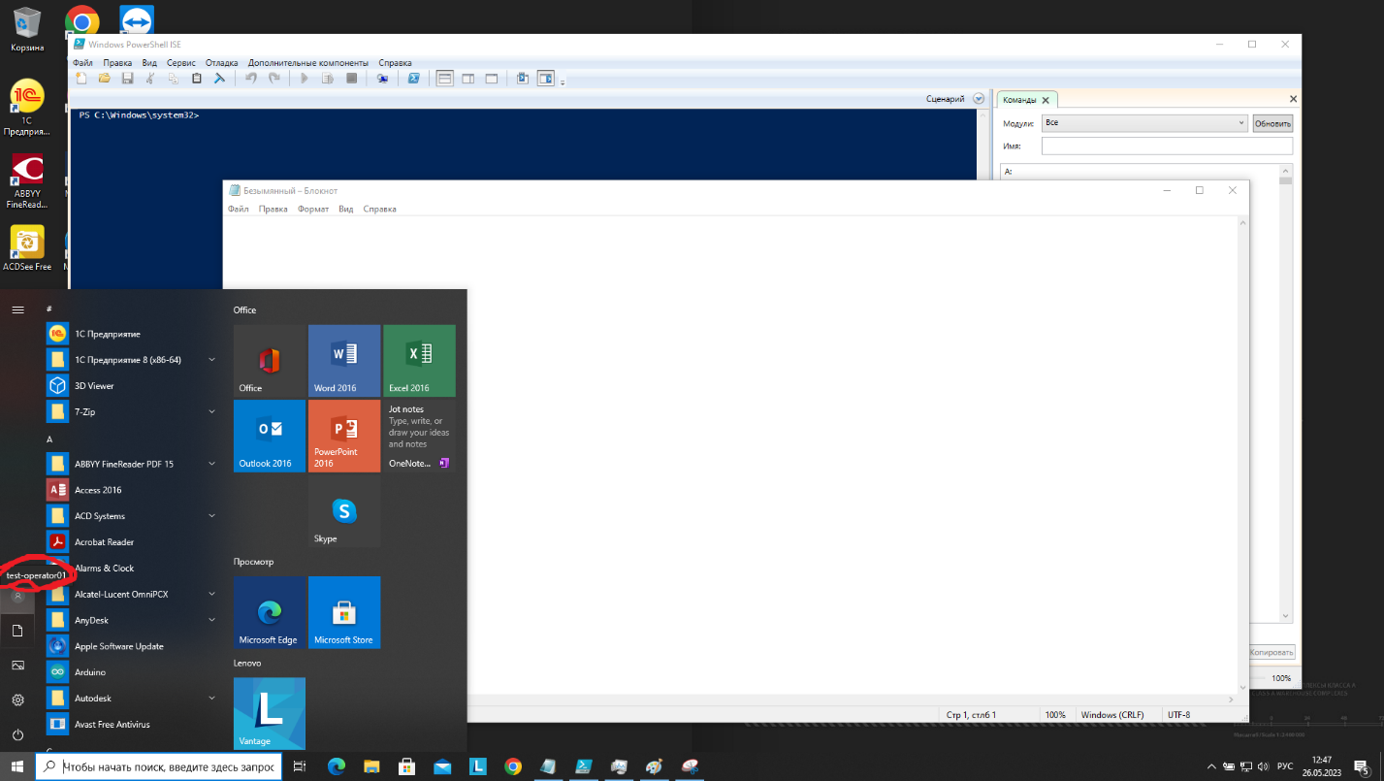

* скриншот предупреждения после попытки «пользователя» запустить regedit.
* скриншот пользователя с SF_CLIENT (скрин рабочего стола);

